# CS 255 Business Requirements Document Template

Complete this template by replacing the bracketed text with the relevant information.

This template lays out all the different sections that you need to complete for Project One. Each section has guiding questions to prompt your thinking. These questions are meant to guide your initial responses to each area. You are encouraged to go beyond these questions using what you have learned in your readings. You will need to continually reference the interview transcript as you work to make sure that you are addressing your client’s needs. There is no required length for the final document. Instead, the goal is to complete each section based on your client’s needs.

**Tip:** You should respond in a bulleted list for each section. This will make your thoughts easier to reference when you move into the design phase for Project Two. One starter bullet has been provided for you in each section, but you will need to add more.

## System Components and Design

### Purpose

*What is the purpose of this project? Who is the client and what do they want their system to be able to do?*

Client: DriverPass

Purpose: The purpose of this project is to develop an integrated system for DriverPass that provides comprehensive training for driving tests, including online classes, practice tests, and on-the-road training. DriverPass aims to reduce the number of people failing their driving tests by offering thorough preparation and tracking their progress.

### System Background

*What does DriverPass want the system to do? What is the problem they want to fix? What are the different components needed for this system?*

Problem: Many people fail their driving tests at the DMV due to inadequate preparation and training.

Solution: DriverPass wants to offer a system that includes online classes, practice tests, and on-the-road training sessions. This system should facilitate scheduling, tracking progress, and providing feedback to improve the success rate of their customers in passing the driving test.

### Objectives and Goals

*What should this system be able to do when it is completed? What measurable tasks need to be included in the system design to achieve this?*

Objectives and Goals:

The system should allow users to access data online from any device.

The system should enable customers to register, schedule, modify, and cancel driving lessons online.

The system should track user actions and generate activity reports for accountability.

The system should support different user roles with specific access rights.

The system should integrate with the DMV to ensure training materials are current.

The system should provide secure access and data exchange.

The system should offer downloadable reports for offline work.

The system should include a user-friendly interface for all user roles.

## Requirements

### Nonfunctional Requirements

*In this section, you will detail the different nonfunctional requirements for the DriverPass system. You will need to think about the different things that the system needs to function properly.*

#### Performance Requirements

*What environments (web-based, application, etc.) does this system need to run in? How fast should the system run? How often should the system be updated?*

The system shall run in a web-based environment.

The system shall load and respond within 2 seconds under normal usage.

The system shall be updated as needed, with major updates scheduled quarterly.

#### Platform Constraints

*What platforms (Windows, Unix, etc.) should the system run on? Does the back end require any tools, such as a database, to support this application?*

The system shall run on all major web browsers (Chrome, Firefox, Edge, Safari).

The backend shall utilize a cloud-based database solution (e.g., AWS, Azure) for scalability and security.

#### Accuracy and Precision

*How will you distinguish between different users?* *Is the input case-sensitive? When should the system inform the admin of a problem?*

The system shall distinguish users by unique usernames and passwords.

The input shall be case-sensitive for passwords but case-insensitive for usernames.

The system shall inform the admin of login failures, unauthorized access attempts, and data discrepancies.

#### Adaptability

*Can you make changes to the user (add/remove/modify) without changing code? How will the system adapt to platform updates? What type of access does the IT admin need?*

The system shall allow admins to add, remove, or modify user roles without changing code.

The system shall be designed to handle platform updates with minimal disruption.

The IT admin shall have full access to manage user accounts, system settings, and data integrity.

#### Security

*What is required for the user to log in? How can you secure the connection or the data exchange between the client and the server? What should happen to the account if there is a “brute force” hacking attempt? What happens if the user forgets their password?*

Users shall log in using a username and password.

The system shall use HTTPS for secure data exchange between the client and the server.

The system shall lock an account after five failed login attempts and notify the admin.

Users shall be able to reset their passwords through a secure, automated process.

### Functional Requirements

*Using the information from the scenario, think about the different functions the system needs to provide. Each of your bullets should start with “The system shall . . .” For example, one functional requirement might be, “The system shall validate user credentials when logging in.”*

The system shall validate user credentials when logging in.

The system shall allow users to register and create accounts.

The system shall enable users to schedule, modify, and cancel driving lessons online.

The system shall track and log all user actions for accountability.

The system shall generate and allow download of activity and progress reports.

The system shall support different user roles with specific permissions.

The system shall integrate with DMV systems to receive updates on training materials.

The system shall allow admins to manage user accounts and access rights.

### User Interface

*What are the needs of the interface? Who are the different users for this interface? What will each user need to be able to do through the interface? How will the user interact with the interface (mobile, browser, etc.)?*

Interface Needs: Intuitive, user-friendly design, accessible on multiple devices (mobile, tablet, desktop).

Users and Needs:

Owner (Liam): Access all system data, generate reports, track progress.

IT Officer (Ian): Manage system settings, user accounts, and data integrity.

Secretary: Schedule and manage appointments, handle customer queries.

Customers: Register, schedule, modify, and cancel lessons, view progress.

Interaction: The interface shall be web-based, accessible through browsers on mobile and desktop devices.

### Assumptions

*What things were not specifically addressed in your design above? What assumptions are you making in your design about the users or the technology they have?*

Assumptions:

Users have access to the internet and modern web browsers.

Users are familiar with basic web navigation.

The cloud service used will handle backups and security updates.

### Limitations

*Any system you build will naturally have limitations. What limitations do you see in your system design? What limitations do you have as far as resources, time, budget, or technology?*

Limitations:

Dependence on internet connectivity for most functionalities.

Initial budget constraints may limit advanced features.

Time constraints may impact the scope of initial release features.

Limited by the chosen cloud provider's features and capabilities.

### Gantt Chart

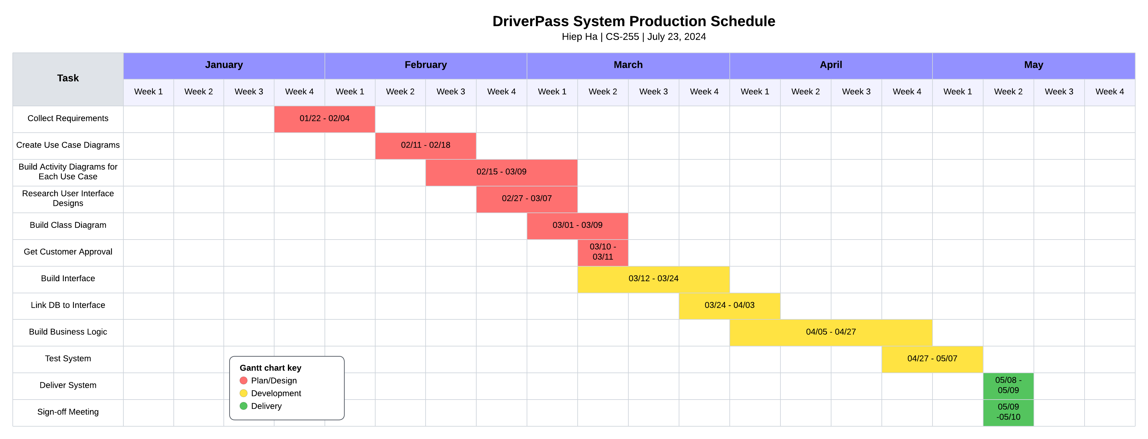*Please include a screenshot of the GANTT chart that you created with Lucidchart. Be sure to check that it meets the plan described by the characters in the interview.*